Michigan Society for Healthcare Central Service Professionals invites you to Attend

SUCCESSFUL TEAMWORK DRIVES DREAMWORK!
LET’S MOVE FORWARD TOGETHER!

When:
May 17th & 18th, 2024
Where:

Club Venetian 29310 John R Rd.,
Madison Heights, MI 48071 248-399-6788

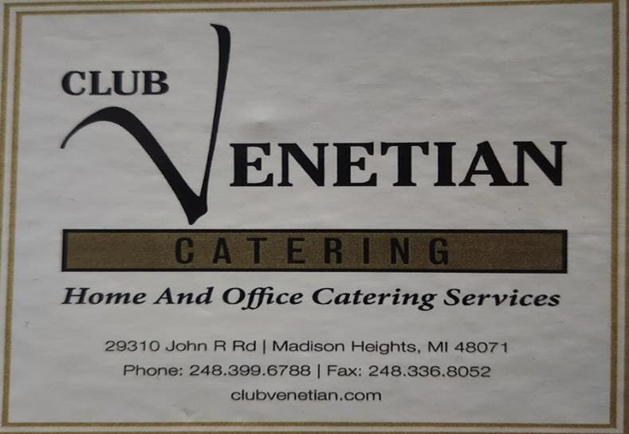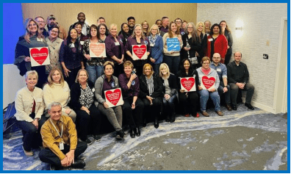
www.mshcsp.net
Join us for the 47th Annual Meeting and Educational Conference!

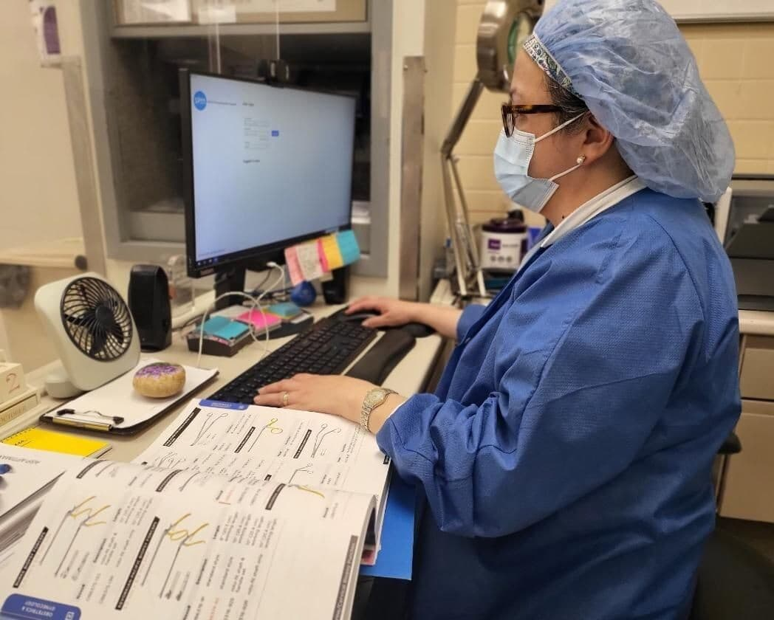
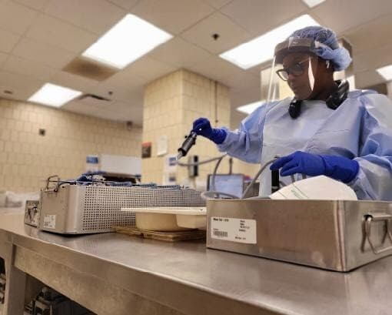
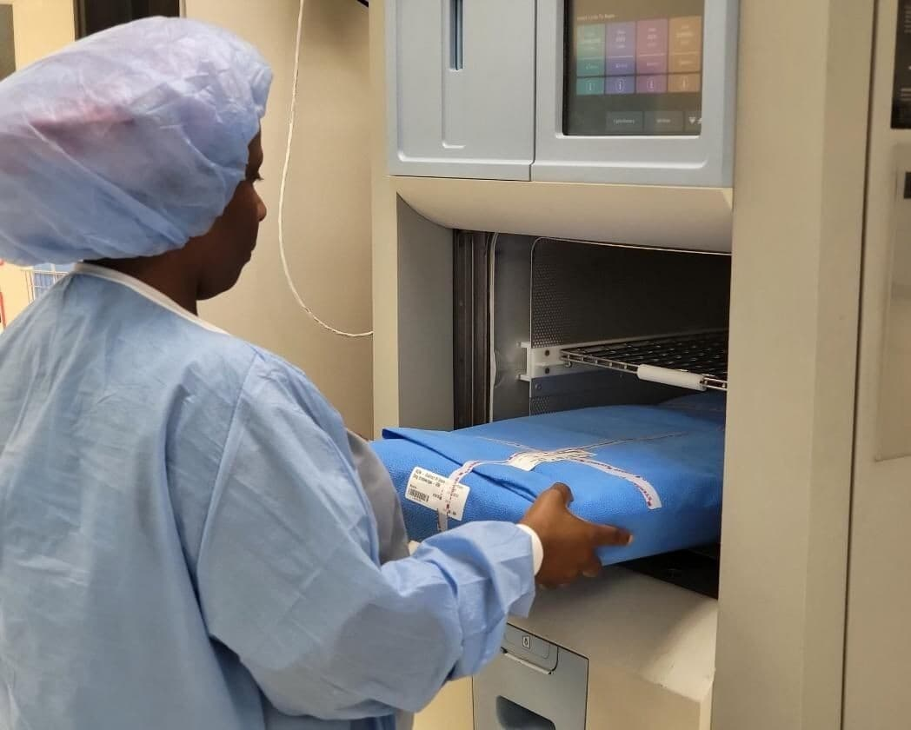
WHO SHOULD ATTEND?
- MSHCSP Members
- Central Service/OR Personnel
- Instrument/ Sterilization Personnel
- Surgical Technologists
- OR/cs Educators
- Operating Room Directors/Managers
- Directors/Managers CS /Materials Management
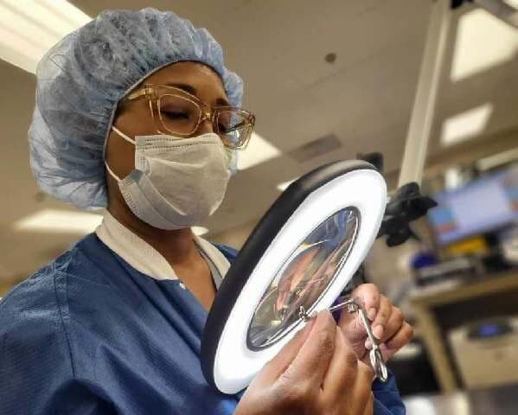
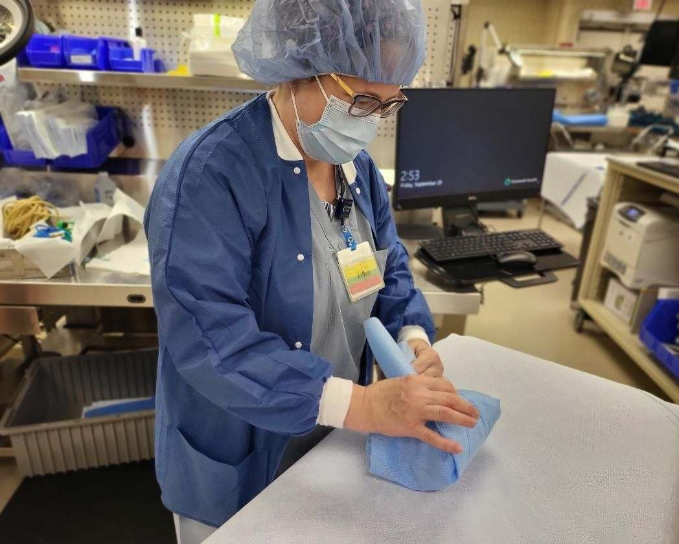
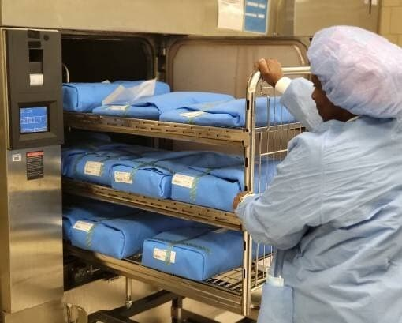
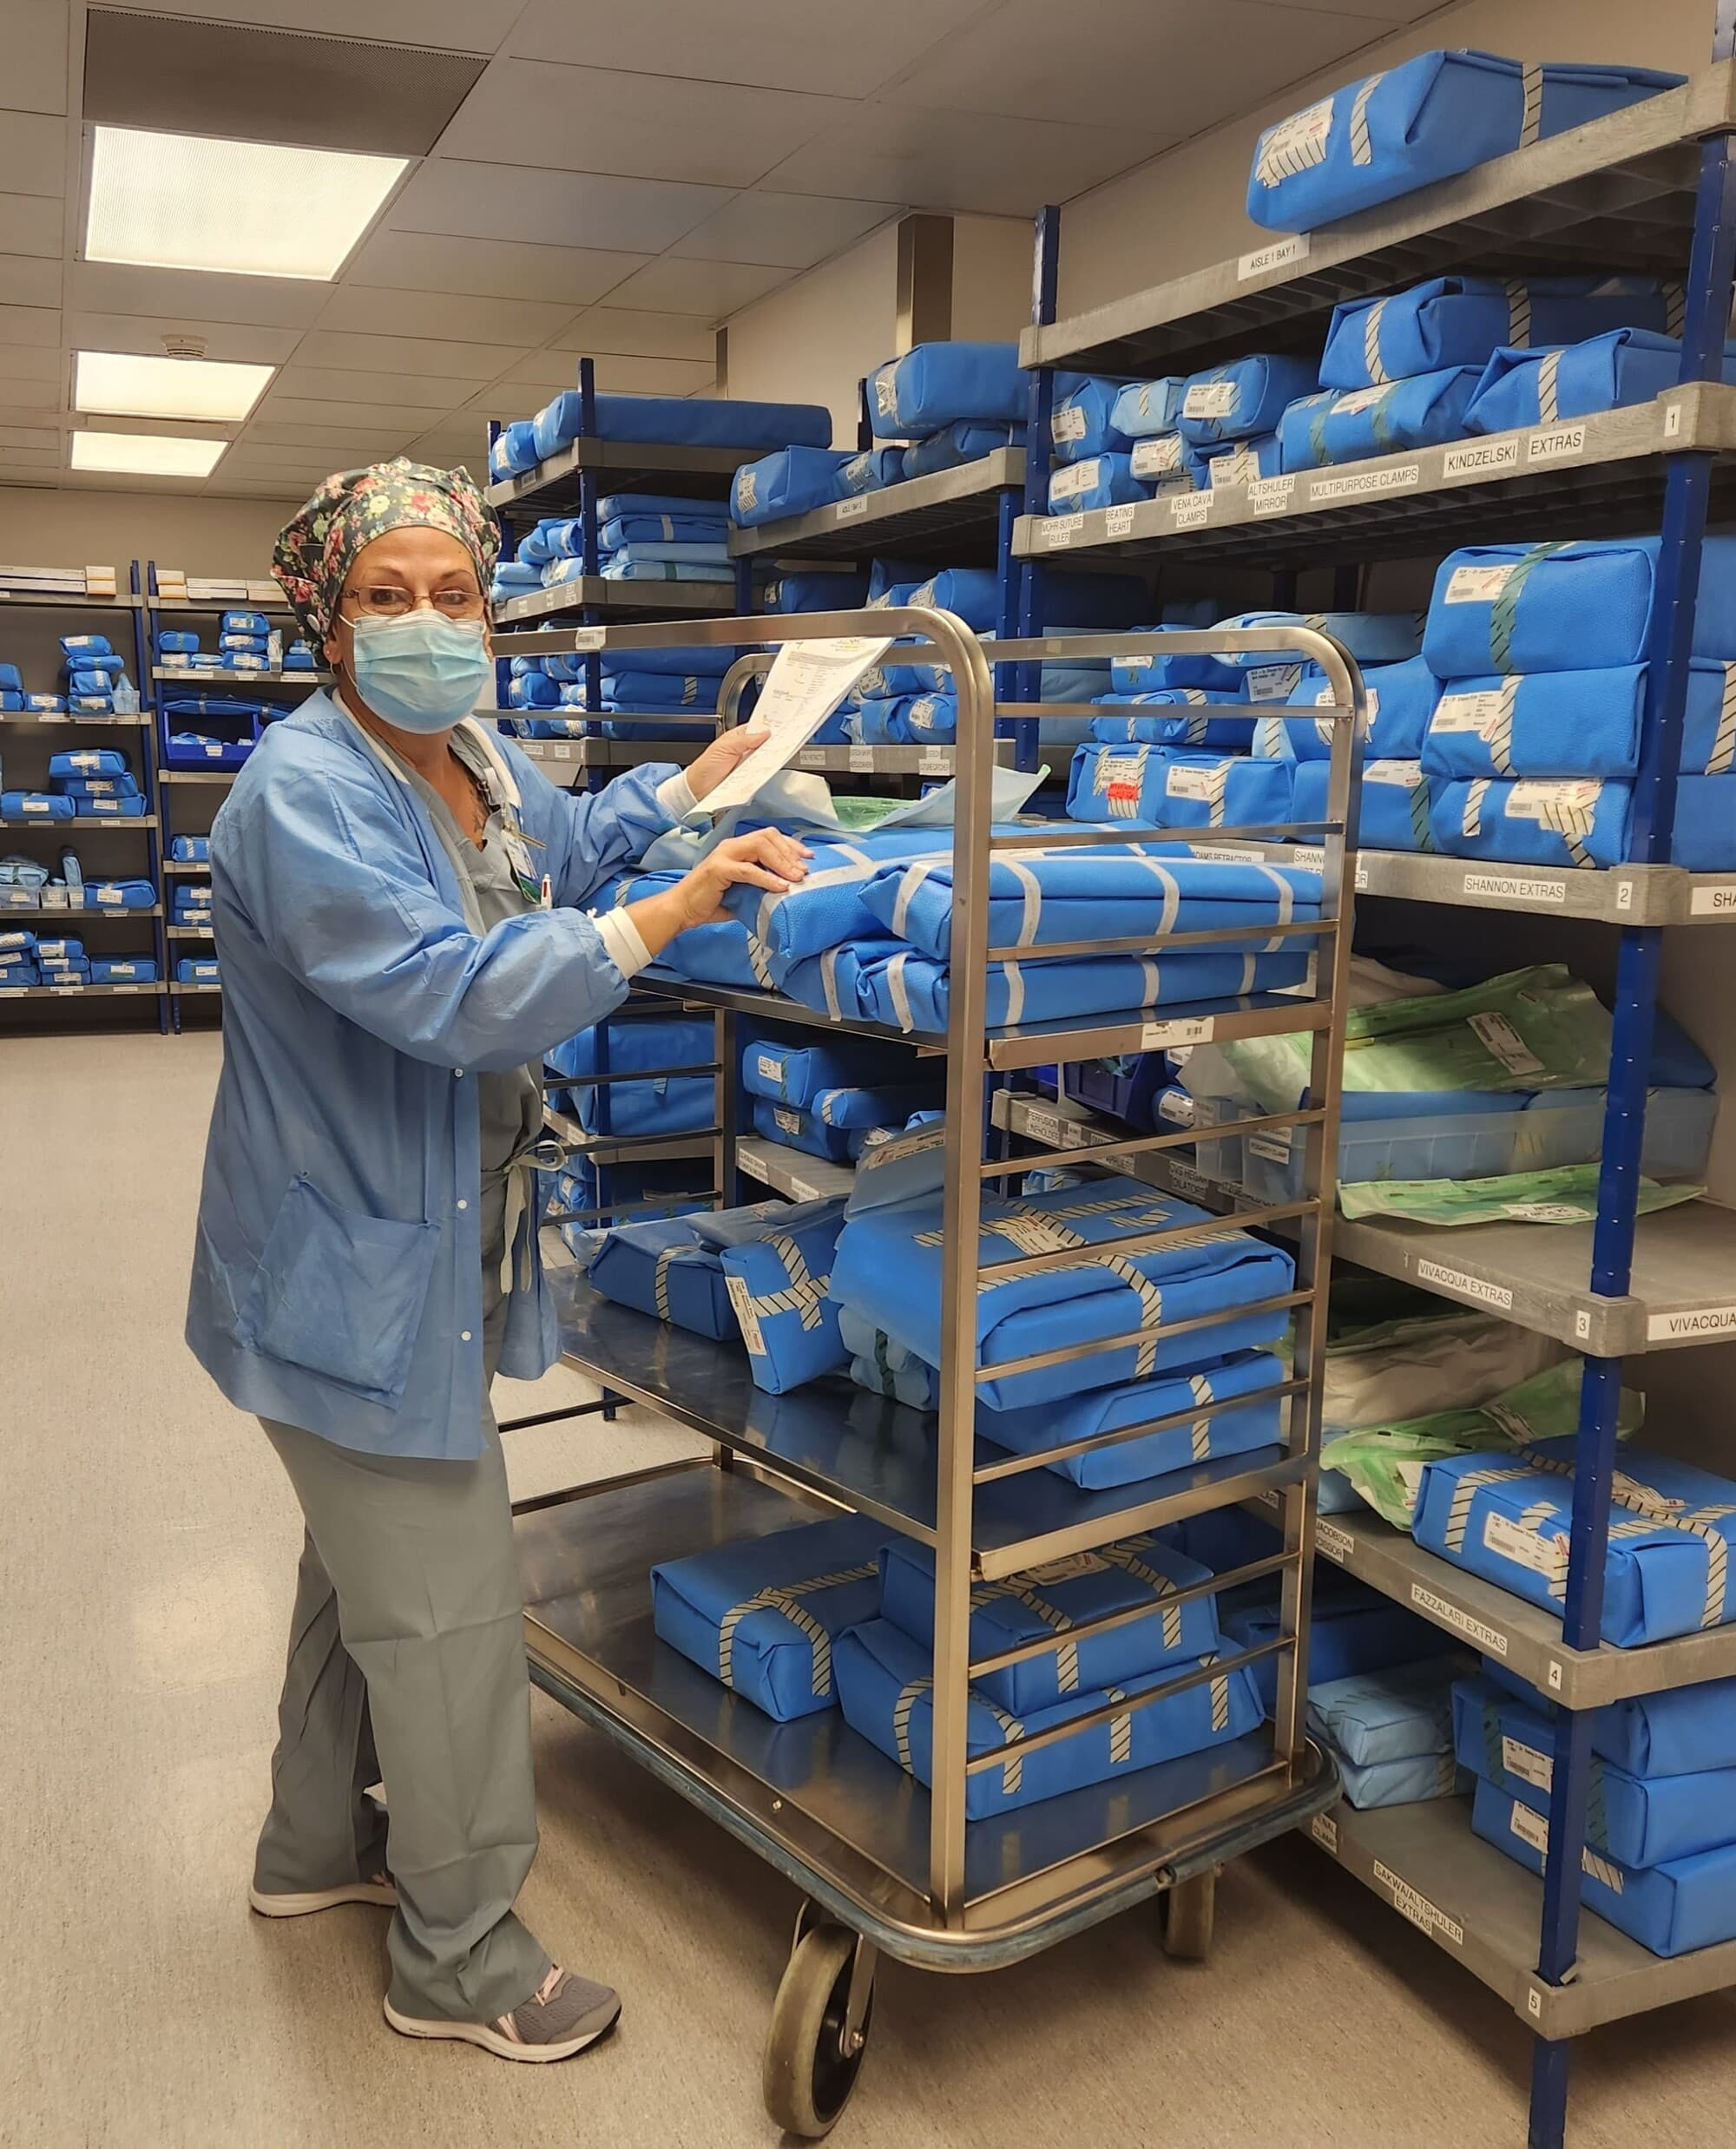
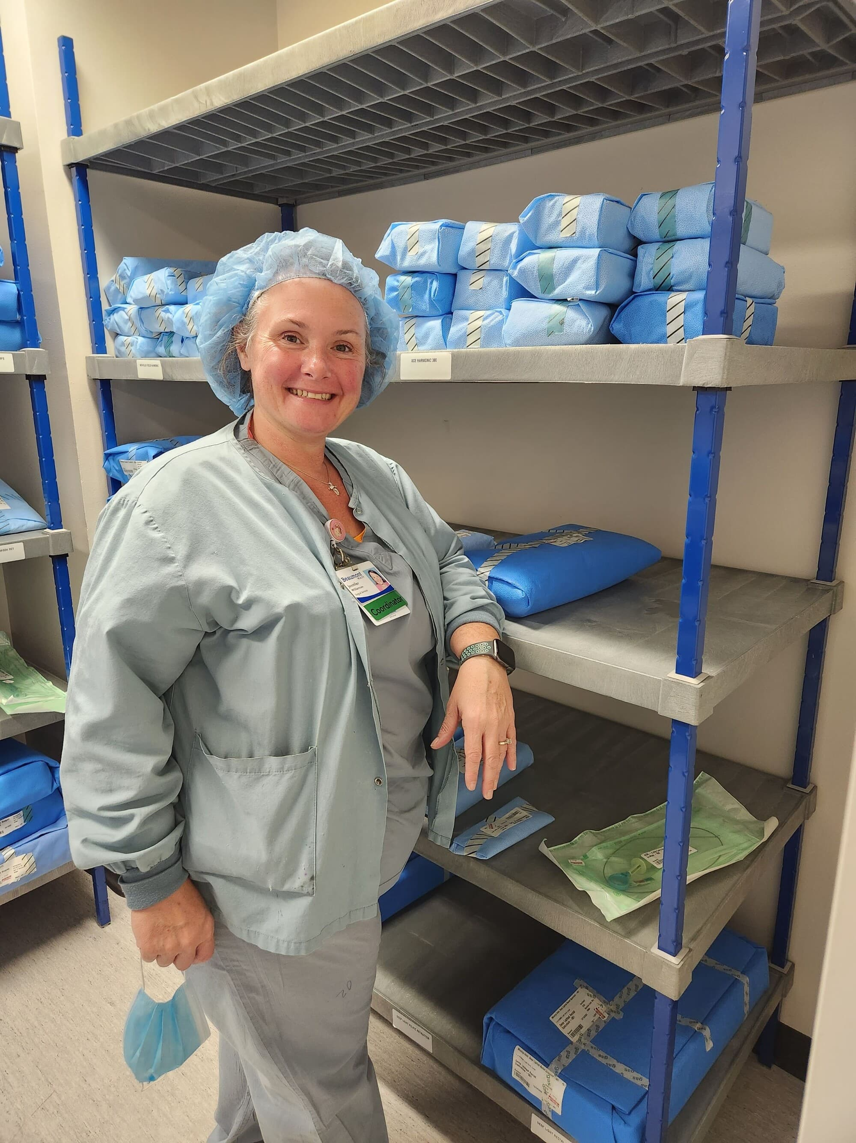
- Infection Control Professionals

Schedule
Golfing will be available on Friday! 29600 John R. Rd., Madison Heights 48071 248-541-5030
Friday, May 17th
Saturday, May 18th
Good to Know

7:00 – 8:00  AM | Registration & Coffee  Sponsored by: MSHCSP
8:00 – 8:15  AM | Welcoming and Opening Remarks  SPEAKER: Joan Wakefield-Griffith,  MSHCSP President
8:15 – 9:30  AM | “Attitude Touches Everything, But Shouldn’t it?”  SPEAKER:Cheron Rojo  Sponsored by: HealthMark
9:30 – 9:45  AM | BREAK  Sponsored by: MSHCSP
9:45 –  11:00 AM | “Driving to Zero:The Rationale for Every Load Monitoring Across Sterilization Modalities”  SPEAKER:Sarah Sholes Antonelli  Sponsored by: 3M
11:00 –  12:00 PM | VENDOR SHOW  View the latest Products and Innovations  in the healthcare marketplace. Up to 25 vendor  exhibits!
12:00 –  1:00 PM | Lunch with Vendors  Sponsored by: MSHCSP
1:00 – 2:15  PM | “Bring It On Kahoot VH202 Gamification”  SPEAKER:Sarah Sholes Antonelli  Sponsored by:3M
2:15 – 3:30  PM | “The Impact of Water Quality for SPD”  SPEAKER:Brian Battani  Sponsored by: Evoqua /xylem
3:45 – 5:00  PM | “Steam Sterilization”  SPEAKER:Janet Strong  Sponsored by:Steris
5:05 – 5:20  PM | The Tradition Continues: Closing Awards,  Remarks, Raffle, Adjournment

12:00-2:30 PM | MSHCSP Annual Business Meeting
4:00-5:00PM | Registration
5:15-6:00 PM | “What Am I Looking at? A Dive into the Rabbit Hole of Lumen Inspection”  SPEAKER:Cheron Rojo  Sponsored by:Healthmark
6:15 – 7:00 PM | “Collaboration for Positive Outcomes”  SPEAKER:Loraine Durigan  Sponsored by:Integra
7:15-10:00 PM | Welcoming Social Event  Sponsored by: MSHCSP

CONTINUING EDUCATION | Contact hours have been applied for attending this program through CBSPD &  HSPA (IAHCSMM)
EXHIBITS | There will be up to 25 product booths. Don’t miss this opportunity to view current technologies and products as well as networking with the vendors and your peers! The social hour (appetizers), centennial breakfast, lunch is included in  your 1 day and ½ conference registration.
LOCATION | The conference will be held at Club Venetian 29310 John R. Rd.,  Madison Heights, MI 48071

Hotel Available:
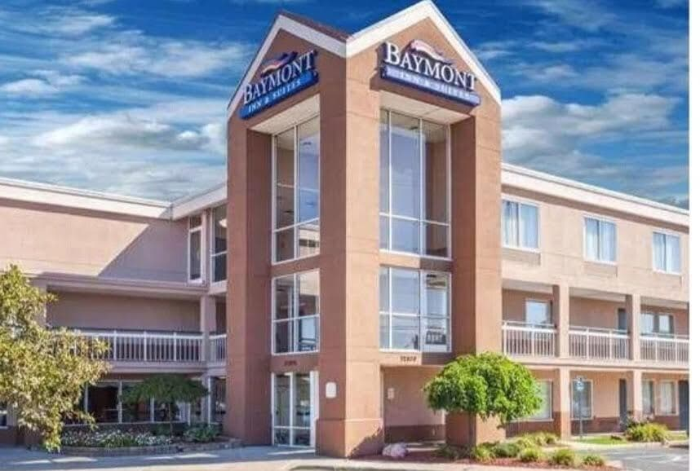
BAYMONT by WYNDHAM
32800 Stephenson Hwy
Madison Heights Mi 48071
248 588-3388

Register

MSHCSP Conference May 17th & 18th, 2024
Club Venetian 29310 John R. Rd., Madison Heights, MI 48071
Choose one of the following categories and complete that section
This includes:
all social functions, banquet ticket and all educational offerings
2023/2024 membership is included with paid 1 and 1/2-day conference registration
__ $80.00 current member
__ $90.00 non-member
__ $45.00 student with I.D.
1 day of conference  __ $35.00 Friday  __ $65.00 Saturday | HSPA Approved for 8.0CE  CBSPD Approved for 8.0CE
DO YOU HAVE ANY FOOD RESTRICTIONS________________________________________________________
Attendee Information MSHCSP #__________ HSPA #__________ CBSPD#___________
Name_______________________________Title_______________
Home address ______________ ____ City, State, Zip_________________ Phone________________
E-Mail__________________
Make check/ money order payable to: MSHCSP (we do not accept purchase orders)
Registration Fee $_______
Total amount enclosed $_______
Mail payment and form to:
MSHCSP
PO BOX 20434
Ferndale, MI 48220

Refund policy: Cancellations/refunds allowed up to 10 days before the conference (postmarked by March 7,2024) Minus a $25.00 processing fee. Any nonsufficient returns on checks will be charged an additional $30.00 fee!

